SQL_Assignments_Set 6

- Display the oldest employee in the deptno 30.

SELECT * FROM EMP
WHERE HIREDATE = (SELECT MIN(HIREDATE)
FROM EMP
WHERE DEPTNO=30)
- Display the records of employees who earn salary less than the average salary of job SALESMAN. The records of SALESMAN should be excluded from the report.

SELECT * FROM EMP
WHERE SAL < (SELECT AVG(SAL)
FROM EMP
WHERE JOB = 'Salesman')
and JOB <> 'salesman'

- Display the top earner’s records from the job CLERK.

SELECT * FROM EMP
WHERE SAL = (SELECT MAX(SAL)
FROM EMP
WHERE JOB = 'CLERK')

- Display the name, hire date, and salary for all employees who have both the same salary and commission as Scott.
Note: Do not display SCOTT in the result set.

SELECT ENAME, HIREDATE, SAL FROM EMP
WHERE (SAL = (SELECT SAL
FROM EMP
WHERE ENAME = 'SCOTT')
OR COMM = (SELECT COMM
FROM EMP
WHERE ENAME = 'SCOTT'))
AND ENAME <> 'SCOTT'

- Display the department names of employees who have their salary greater than Martin’s salary.

SELECT E.ENAME D.DNAME
FROM EMP E , DEPT D
WHERE SAL >(SELECT SAL
FROM EMP
WHERE ENAME = 'MARTIN')
AND E.DEPTNO = D.DEPTNO

6) Produce the following output—

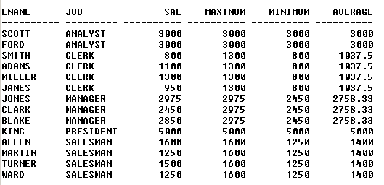

SELECT E1.ENAME, E2.JOB, E1.SAL, E2.Maximum, E2.Minimum, E2.Average
FROM EMP E1 JOIN (SELECT JOB, MAX(SAL) AS 'Maximum', MIN(SAL) AS 'Minimum', AVG(SAL) as 'Average'
FROM EMP GROUP BY JOB) as e2
ON E1.JOB = E2.JOB
ORDER BY JOB

7. Display the records of employees who earn salary above the average salary of SALESMAN job excluding the MANAGER jobs.

SELECT * FROM EMP
WHERE SAL > (SELECT AVG(SAL)
FROM EMP
WHERE JOB = 'SALESMAN')
AND JOB <> 'MANAGER'

8. Produce the following output

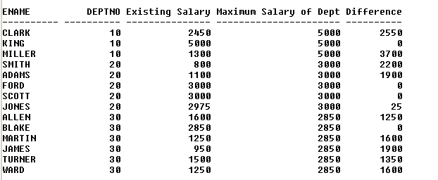

SELECT E1.ENAME,E1.DEPTNO,E1.SAL,E2.Maximum,(E2.Maximum-E1.SAL) AS 'Difference'
FROM EMP E1 LEFT JOIN (SELECT TOP 3 DEPTNO, MAX(SAL) AS 'Maximum' FROM EMP GROUP BY DEPTNO ORDER BY Maximum DESC) as e2
ON E1.DEPTNO = E2.DEPTNO
ORDER BY E1.DEPTNO, E2.Maximum DESC

9. Display the department name that has the highest salary record.

SELECT D.DNAME
FROM EMP E, DEPT D
WHERE E.SAL = (SELECT MAX(SAL)
FROM EMP)
AND E.DEPTNO = D.DEPTNO

